Password Protecting a PDF File using Adobe Acrobat DC
- Click on “Tools” and click on “Protect”
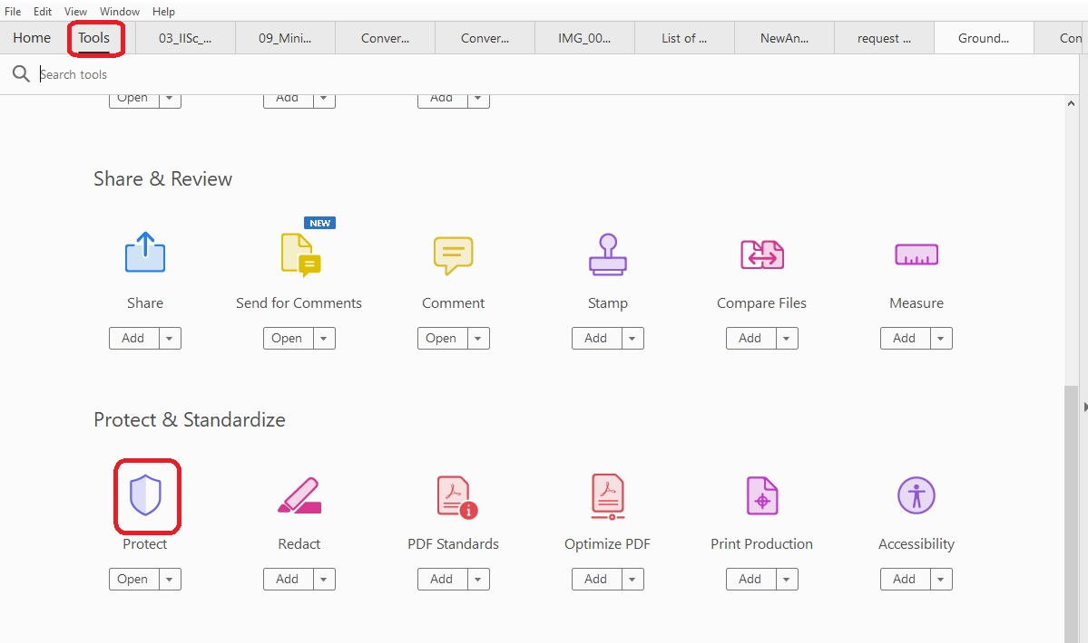

- Click on “Protect Using Password”.

- Select “Viewing”, enter and re-enter Password and click on “Apply”.
