**TENDER FOR OPERATION & MAINTENANCE OF WATER SUPPLY AND SEWERAGE SYSTEM**

**IN IISc CAMPUS**

|  |
| --- |
| **Addendum** |
| **Agencies interested in participating in the tender are required to communicate the same by sending an email to drcmc@admin.iisc.ernet.in on or before July 20th 2016. They can also send any clarification/questions on the tender on or before July 20th 2016. Sending an email expressing the interest in participating the tender is desirable (but not mandatory) and will help us to communicate with the agenices regarding tender clarification etc.** |

**TENDER NO. R(CMC)WSSS/2016-06 DATED30/6/2016**

**(**[**http://www.iisc.ernet.in/tender/WaterOandM.html**](http://www.iisc.ernet.in/tender/WaterOandM.html)**)**



**CONTRACT MANAGEMENT CELL**

**INDIAN INSTITUTE OF SCIENCE**

**BANGALORE-560 012**

**GENERAL DEFINITIONS**

1. IISc.,or Institute means, The Indian Institute of Science, Bangalore.
2. “Director” means, The Director of IISc., or his authorized representative.
3. “Registrar” means, The Registrar of IISc., or his authorized representative.
4. ‘Areas’ means, areas in the Main Campus (incl. the CSIC/SID part), Gymkhana area (incl. KRVH Quarters), Yeswanthpur Quarters, Aryabhatta Quarters area, HMT Quarters area, Vijnanapura Campus and any other areas specified by the Registrar/ his authorised representative.
5. The selected agency/service provider means the successful bidder.

**SCHEDULE OF EVENTS**

**Schedule A**

|  |  |
| --- | --- |
| Tender No. | R(CMC)WSSS/2016-06 Dated 30/6/2016 |
| Prebid Clarification Meeting | 13/7/2016, 3.00 p.m. |
| Last date for receipt of bids | 29/7/2016, 3.00 p.m. |
| Validity of bid: | 90 days from the date of opening of technical bid |
| Tender Fee (Non refundable) | Rs. 10,000.00 (to be submitted as a Demand Draft, drawn in favour of REGISTRAR, Indian Institute of Science, Bangalore payable at BANGALORE, along with the technical bid) |
| Earnest Money Deposit | Rs. 1.00 lakh  In the form of Demand Draft in favour of REGISTRAR, Indian Institute of Science, Bangalore payable at BANGALORE, to be submitted along with the technical bid |
| Date & Time of opening of Technical Bid: | 29/7/2016, 4.00 p.m. |
| Place of opening the bids: | Contract Management Cell,  Indian Institute of Science,  Bangalore-560 012 |
| Date & Time of opening of Financial Bid: | To Communicated Later |
| Contract Commencement Date: | 01/08/2016 (tentative) |
| Contract Duration: | 3 years (renewable each year after review) |
| Performance Security Deposit | 10% of the annual contract value |
| FINANCIAL Turn-over of bidders: | Rs. 300 lakhs per annum in the preceding three years (2012-15) |

**TENDER NOTICE**

Sealed tenders are invited under **Two Bid System** i.e., Technical Bid (accompanied by EMD, by way of Crossed Demand Draft drawn in favour of **The Registrar, Indian Institute of Science, Bangalore**) and Financial Bid from reputed, experienced and financially sound **Companies/Firms/Agencies/Contractors.**

The Technical Bid and the Financial Bid shall be submitted in separate covers duly sealed and superscribed as TECHNICAL & FINANCIAL BID. These two covers shall be submitted in a single cover duly sealed and superscribing the Name of the work with Name and Address of the Tenderer and addressed to the undersigned.

**Essential Requirement of the Bidder/Agency/Firm:**

1. The bidder/ Company / Firm / Agency should be registered with the appropriate registration authority (labour commissioner etc.).
2. The bidder/Company/Firm/Agency should have atleast five years experience in providing Operations & Maintenance Service of water supply and sewerage of similar capacity/volume to Public Sector Companies / Banks / Government Departments / Research Organizations/Reputed Private Sector Companies.
3. The Company/Firm/Agency should have executed a single work of similar nature in Government/Semi Government/Reputed Private Firm costing for not less than Rs. **100.00 lakhs**in any one of the financial year during the block period of preceding three years (2013-16).
4. The bidder /Company / Firm / Agency should be registered with Income Tax and Service Tax departments;
5. The bidder /Company / Firm / Agency should be registered with appropriate authorities under Employees Provident Fund and Employees State Insurance Acts.
6. The agency must have Registered Office in Bangalore or should set up a Branch Office in Bangalore within one month, if they take up the contract.
7. The agency should open bank account inside the IISc., campus for transaction with regard to the contract with IISc.,
8. The bidder /Company / Firm / Agency should have its own Bank Account;
9. The bidder /Company/Firm/Agency should have a minimum FINANCIAL turnover during the last three years as specified in Schedule A.

**Obligations of the agency:**

1. The agency should employ men/women aged between18 (and preferably below 55), who have good health and clean conduct record.
2. The agency should employ personnel who can converse well in English and local language.
3. The agency should provide at least 2 sets of Uniforms to all personnel employed by them.
4. The agency should provide necessary tools and equipments that are necessary for the Operation and maintenance of Water supply/sewerage system.

**GENERAL INSTRUCTIONS FOR BIDDERS**

1. The bids are invited under **two bid system i.e. Technical Bid and Financial Bid in separate sealed covers, superscribed respectively as “Technical Bid” and “Financial Bid” along with the Tender No. as given in Schedule A.** Both sealed envelopes should be put in another sealed envelope superscribed as “Tender for Operation and Maintenance of Water Supply &Sewerage System in IISc campus.
2. The bidder shall tender the Technical & Financial bids as per the format enclosed at Annexure II & III.
3. The bidder is required to enclose photocopies of the necessary documents as listed in Annexure IV.
4. The Technical Bid should be accompanied with an Earnest Money Deposit (EMD) as stated in Schedule A.
5. The proof of the annual turn-over for the previous years in the form of audited balance sheet or statement of accounts shall be provided, failing which the tender is liable to be rejected.
6. The bidder should include the list of organisations where they have provided similar services in the last 5 years, along with name, phone and fax number of the contact person there, so that references for their services can be obtained, if required.
7. All entries in the bid form should be legible and filled clearly. If the space for furnishing information is insufficient, a separate sheet duly signed by the authorized signatory may be attached. **No overwriting or cutting is permitted in the Financial Bid Form. In such cases, the tender is liable to be rejected.** Cuttings, if any in the Technical Bid must be initialled by the person authorized to sign the bid.
8. The envelope containing Technical Bid shall be opened first on the scheduled date and time as given in Schedule A in the presence of representatives of the Companies, Firms/Agencies, who wish to be present on the spot at that time.
9. Technical Bids will be evaluated by a committee. The technical evaluation will include checking the financial turn-over, experiences, registration certificates, legal, financial, statutory, taxation and other associated compliance of existing contracts. The committee will evaluate the performance of the agency in their existing contracts/earlier contracts which may include obtaining references and/or visiting the work site, and the quality of the manpower deployed by them.
10. Financial bids of technically qualified, eligible bidders meeting all the requisite criteria shall be opened on a date & place (to be notified later) in the presence of short-listed bidders or their authorized representatives.
11. IISc reserves the right to amend or withdraw any of the terms and conditions contained in the Tender Document or to reject any or all tenders without giving any notice or assigning any reason. The decision of the Director of IISc, in this regard is final and binding on all.

**TERMS AND CONDITIONS**

**General**

1. Bids submitted after the deadline shall not be accepted under any circumstances whatsoever.
2. Any conditional bid is liable to be rejected.
3. Bids not following the two-cover format, or those that includes price information in the technical bid shall be rejected.
4. The Earnest Money Deposit (EMD), refundable (without interest), should be necessarily accompanied with the Technical Bid of the agency in the form of Demand Draft / Pay Order from any of the Scheduled bank drawn in favour of The Registrar, IISc payable at Bangalore valid for a period of 90 days. Offers not accompanied by EMD of the requisite amount or without proper validity will be summarily rejected.
5. The Earnest Money will be forfeited if the bidder rescinds from the offer.
6. Bids offering rates which are lower than the current central government minimum wages for the pertinent category would be rejected.
7. The contract is for the duration specified in Schedule A. The contract will be reviewed yearly, and only upon satisfactory performance, will be extended for 1 year at a time, until the duration of the contract.
8. The contract may be extended, on same terms and conditions, for further periods, subject to a maximum of 1 year beyond the contract term specified in Schedule A.
9. The selected agency is required to execute an agreement within 15 days of the award of the work.
10. The scope of the contract can be extended to additional manpower, with a proportional increase in contract value, as mutually agreed upon, and approved by the competent authority of IISc.
11. The contract may be terminated before the contract period owing to deficiency in service or substandard quality of service provided by the selected company/Firm/Agency. Further, IISc reserves the right to terminate the contract at any time after giving two months notice to the successful bidder.
12. The bidder shall not be allowed to transfer, assign, pledge or sub-contract its rights and liabilities under the contract to any other agency without the prior written consent of IISc.
13. The bidder will be bound by the details furnished by him/her to IISc, while submitting the bid or at subsequent stage. In case, any of such documents furnished by the firm is found to be false at any stage, it would be deemed to be a breach of terms of contract making the firm liable for legal action besides termination of contract.
14. The selected agency shall furnish a Performance Security Deposit in the form a bank guarantee in Scheduled / Nationalized bank, as specified in the Schedule A at the time of placing the work order within 15 days of the receipt of the formal order. The performance security will be furnished in the form of the Bank Guarantee/Demand Draft drawn in favour of The Registrar, IISc, Bangalore-12 payable at Bangalore. The performance security should remain valid for a period of 3 years 2 months. The performance security will be returned on termination of the contract and completion of all the contractual obligations of the successful bidder.
15. The agency shall ensure that the manpower deployed in IISc, are physically fit, well trained and are preferably in the age group of 18-55 years. The bidder shall ensure that the manpower deployed in IISc, conforms to the technical specifications of age and language skills prescribed in the section on Scope of Work of the Tender Document.
16. The successful bidder shall furnish the following documents in respect of the individual manpower who will be deployed in IISc, before the commencement of the work.
17. List of manpower shortlisted by agency for deployment at IISc, containing full details ie., date of birth, marital status, address, etc.
18. Bio-data of the persons.
19. Character Certificate from a Gazetted Officer of the Central/State Government.
20. Certificate of verification of antecedents of persons by local police authority.
21. In case, the person employed by the agency commits any act of omission/commission that amounts to misconduct/indiscipline/incompetence/security risks, the successful bidder will be liable to take appropriate disciplinary action against such persons, including their removal from work, immediately after being brought to notice, failing which it would be assumed as breach of contract which may lead to cancellation of contract.
22. The selected agency shall provide identity cards to the personnel deployed carrying the photograph of the personnel and personal information such as name, date of birth, age and identification mark, etc.
23. The selected agency shall ensure that any details of office, operational process, technical knowhow, security arrangements, and administrative/organizational matters are not divulged or disclosed to any person by its personnel deployed.
24. The selected agency shall ensure proper conduct of his personnel and enforce prohibition of consumption of alcoholic drinks, paan, smoking, loitering without work, etc.
25. The selected agency shall designate an Engineer as coordinator, who would be responsible for immediate interaction, so that optimal services of the persons deployed by the agency could be availed without any disruption.
26. The selected agency shall immediately provide a substitute in the event of any person leaving the job due to his/her personal reasons. It will be the responsibility of the contractor to meet transportation, food, medical and any other requirement of contractor’s manpower for carrying out the contract works. IISc will have no liability in this regard at any stage.
27. The selected agency undertakes to comply with all statutes, rules, regulations, and bylaws, during the entire period of this contract.
28. All disputes that may arise shall be referred to the Director of IISc, whose decision in this regard shall be final.
29. IISc reserves the right to amend or withdraw any of the terms and conditions contained in the Tender Document or to reject any or all tenders without giving any notice or assigning any reason. The Director, IISc is the final authority for settling any disputes and the decision of the Director in this regard shall be final and binding on all.

**CONTRACT-SPECIFIC**

1. The manpower deployed by the firm/agency is required to work in 3 shifts with staggered weekly off.
2. In addition to the weekly-off, the contract labourers deployed are eligible for 4 holidays (Jan. 26, Aug. 15, Oct. 2, and Nov.1). The contract labourers who have performed shift duty on these days are entitled for an additional shift wage. This can be over and above the 26/27 shifts performed by them.
3. The personnel deployed shall be required to report for work at the specified work spot.

**LEGAL**

1. For all intents and purposes, the bidder shall be the “Employer” within the meaning of different Labour Legislations in respect of manpower so employed and deployed at IISc, for contractual services.
2. The Contractor undertakes to obtain any license, permit, consent, sanction etc. as may be required or called for from/by local or any other authority for doing such work. The Contractor shall comply with all applicable laws, rules and regulations in force. The Contractor undertakes to obtain such permission/license as may be required under the Central Contract Labour (Regulation and Abolition) Act, 1970. The Contractor undertakes to produce the license/permission etc. so obtained to IISc or furnish copies thereof as and when required by IISc. The Contractor also undertakes to keep and get renewed such license, permission etc. from time to time. The Contractor shall be responsible for any contravention of the local, municipal, central, state, any other laws, rules, regulations, etc.
3. The selected agency shall be solely responsible for the redressal of grievances/resolution of disputes relating to persons deployed. IISc, in no way will be responsible for settlement of such issues whatsoever. IISc shall not be responsible for any damages, losses, FINANCIAL or other injury claims to any person deployed by service providing agency in the course of their performing the functions/duties, or for payments towards any compensation.
4. The manpower deployed by the contractor shall not have any claims of Master and Servant relationship vis-à-vis IISc nor have any principal and agent relationship with or against the IISc.
5. The manpower deployed by the contractor for the contract shall not be entitled for claim, pay, perks and other facilities which may be admissible to casual, ad-hoc regular/confirmed employees of IISc, during the currency or after expiry of the contract. In case of termination of the contract also, the persons deployed by the contractor shall not be entitled to or and will not have any claim for absorption or relaxation for absorption in the regular/other category in IISc. The contractor should communicate the above to all the manpower deployed in IISc by the contractor.
6. **The selected agency will be required to pay minimum wages as prescribed under the Minimum Wages Act of Central Government**. The bidder will maintain proper record as required under the Law/Acts.
7. The selected agency will be responsible for compliance of all statutory provisions relating to Provident Fund, and Employees State Insurance etc., in respect of the persons deployed by it at IISc.
8. The selected agency shall also be liable for depositing all taxes, levies, Cess, etc. on account of services rendered by it to IISc & income tax to concerned tax collection authorities from time to time as per extant rules and regulations on the matter.
9. The selected agency shall maintain all statutory registers under the applicable Law. The agency shall produce the same on demand to the concerned authority of IISc or any other authority under Law.
10. The Tax Deduction at Source (T.D.S) shall be deducted as per the provisions of the Tax Department, as amended from time to time and a certificate to this effect shall be provided to the agency by IISc. In addition, labour cess as per current norms (1 %) will be deducted at source.
11. In case, the service provider fails to comply with any statutory / taxation liability under appropriate law, and as a result thereof IISc is put to any loss/obligation, monetary or otherwise, IISc will be entitled to get itself reimbursed out of the outstanding bills or the Performance Security Deposit of the agency, to the extent of the loss or obligation in monetary terms.
12. The selected agency shall ensure that all employees deployed by them at IISc shall be comprehensively insured for accidents and injuries.
13. The selected agency will indemnify IISc from all legal, FINANCIAL, statutory, taxation, and associated other liabilities.

**FINANCIAL**

1. The EMD in respect of the agencies which do not qualify the Technical Bid (First Stage)/ Financial Bid (Second competitive stage)shall be returned to them without any interest. However, the E.M.D. in respect of the successful tenderer shall be adjusted towards the Performance Security Deposit. **Further, if the agency fails to commence work within 15 days from the date of placing the work order, the E.M.D. shall stand forfeited without giving any further notice and the contract will be terminated**.
2. The proof of remittance of statutory deductions of PF, ESI to the appropriate agency, for those employed at IISc, must be provided by the selected agency to IISc every month along with the claim bill, failing which the claim bill shall not be settled.
3. The successful bidder will have to deposit a Performance Security Deposit, as specified in Schedule A, within 15 days of the receipt of the formal order. The Performance Security will be furnished in the form of an account payee Demand Draft/ FDR/ Bank Guarantee, from any Nationalized/Schedule bank, drawn in favour of the Registrar, IISc, Bangalore 560 012, payable at Bangalore. The performance security should remain valid for a period of 3 years and 2 months. The performance security will be returned on termination of the contract and completion of all the contractual obligations of the successful bidder.
4. In case of breach of any terms and conditions attached to this contract, the Performance Security Deposit of the agency will be liable to be forfeited besides annulment of the contract.
5. The agency shall raise the bill, in triplicate, along with attendance sheet (duly verified by Project Engineer cum Estate Officer, CCMD) in respect of the persons deployed and submit the same through the respective departments on or before 18th of the subsequent month. As far as possible the payment will be released within two weeks from the date of submission of bills. The following documents must accompany the bill.
   1. Current month Invoice Copy
   2. Current month Acquittance (Wage) Register duly signed by the individual contract Labourers
   3. Current month Attendance Register
   4. Current month ESI remittance challan with consolidate breakup details
   5. Current month EPF remittance challan, as applicable, with consolidated breakup details
   6. In addition Half yearly returns submitted to EPFO & ESIC are also to be submitted whenever due.
   7. For the services provided by the Contractor, subject to satisfactory completion as certified by IISc, IISc agrees to pay the Contractor as detailed in Annexure III-A. Further, any increase in minimum wages, as per the Central Government Minimum Wages Act, along with proportional increase in the ESI, EPF and agency administrative charges will be borne by IISc. Similarly any increase in the statutory levies (ESI, EPF, Service Tax) will also be applicable automatically and borne by IISc; any decrease in the statutory levies, the benefits will go to IISc. Other than these, during the tenure of the contract, the rates agreed will remain unaltered.
   8. The Contractor hereby agrees that Absenteeism must not exceed 10% of the total deployment in any month. Further within each shift the absenteeism should not be more than 15% of the deployment. The above should be achieved without individual contract labour doing more than the maximum shift allowed by the contract (26/27 shift in a month). Each occurrence of such excess absenteeism in a shift shall entail a deduction of 3% of the service/ administrative charges to the agency for the month, subject to maximum penalty of 30%.
   9. In case the Contractor or any of his employees fails to fulfil his/their obligations for any day or any number of days to the satisfaction of the Institute for any reason whatsoever, the contractor shall pay, by way of liquidated damages, a sum of Rs. 1000.00 (Rupees one thousand only) per day for the entire number of such days and IISc shall, without prejudice to its other rights and remedies, be entitled to deduct such damages from the money, if any, payable by it to the Contractor.
   10. The contract labourers deployed by the agency shall not involve in any theft/pilferage/damage to Institute property. After necessary investigations, if proved that the Agency/their personnel are responsible for the incident, the agency is liable and will be penalized to the extent of the value of the loss and additionally Rs. 10,000/- for each such incident.
   11. The Contractor commits himself to take all measures necessary to prevent corruption. He commits himself to observe the following principles during the contract execution.
   12. The Contractor will not, directly or through any other person or firm, offer, promise or give to any of the Institute’s employees involved in the execution of the contract or to any third person any material or immaterial benefit which he/she is not legally entitled to, in order to obtain in exchange any advantage of any kind whatsoever during the execution of the contract.
   13. The Contractor will not commit any offence under the relevant Anti-corruption Laws of India: further the Contractor will not use improperly, for purposes of competition or personal gain, or pass on to others, any information or document provided by the Institute as part of the business relationship, regarding plans, technical proposals and business details, including information contained or transmitted electronically. The Contractor will not instigate third persons to commit offences outlined above or be an accessory to such offences. The involvement in any such activity shall entail a penalty of Rs. 10,000/- for each such incident.
   14. The claims in bills regarding service Tax etc., if applicable, should be necessarily accompanied with documentary proof pertaining to the concerned month bill. A requisite portion of the bill / whole of the bill amount shall be held up till such proof is furnished, at the discretion of IISc.

**Annexure-I**

**Scope of the work**

1. Operation and Maintenance of Water Supply System.
2. Maintenance of the Sewerage System inside the campus.
3. Operation and Maintenance of Pumps connected to rain water collection sump tanks & rain water harvesting pumps.
4. Maintenance of Re-cycled water supply, pipe line and their fittings, valves, etc.
5. Operation and Maintenance of any additional water supply lines and sewerage lines developed during the contract period.
6. Establishment, Operation & Maintenance of complaint cell (of call centre type) for recording & attending complaints from quarters, departments, Hostels, Guest Houses, centres and central facilities related to Institute, etc.

The Operation and Maintenance envisages all the required tasks to ensure

1. Maximum system availability.
2. Most efficient, effective and optimum usage of water supply & sewerage disposal system.
3. Enhance the life expectancy of equipments.
4. Regular operation and maintenance of equipments.
5. Compliance of safety rules and regulations.
6. Preventive maintenance/scheduled maintenance.
7. Breakdown maintenance.
8. Maximum service to consumers for maintaining uninterrupted water supply & sewerage disposal.
9. Maintenance of proper records of operation and maintenance (Log book, registers, check list etc., which should be approved by Project Engineer cum Estate Officer).
10. Assistance to IISc in expansions and modification of these facilities.

**Operation and Maintenance of Pumping Stations**

1. Switching ON and Switching OFF of pumps as and when required according to requirements/ instructions from Project Engineer cum Estate Officer or his authorized representative.
2. Maintaining records of all the operations and records of water received, water supplied energy consumption on hourly/daily/weekly/fortnightly/quarterly/half yearly and yearly basis.
3. Maintaining records of water supply/sanitary failures with reasons.
4. Monitoring the pumping stations continuously and reporting any problem or faults to the IISc which require major/minor improvements.
5. Maintaining records of maintenance.
6. Interchanging the pumps as and when required.
7. Co-ordination with operators in BWSSB pumping stations for efficient reliable operation of Water Supply System.
8. Attending the faults and restoration of the Water Supply without delay.
9. Following distribution system and maintaining a book to facilitate system maintenance without interruptions.

Taking preventive maintenance such as maintenance of defective pumps, starters, Valves, etc. Contractor has to maintain a check list for preventive maintenance & upkeep the system accordingly. However, contractor has to prepare a detailed check list covering all the required items and submit for IISc approval before being implemented.

The Operation of Water Supply & Sewerage System involves deployment of right persons as mentioned and these persons would be responsible for the work contracted for this purpose. The main jobs will include:

1. Routine Surveillance of Pumping stations, water supply distribution lines, sump tanks & over head tanks.
2. Routine Surveillance of Sewerage system including sewerage lines, manholes, inspection chambers, etc.
3. Filling up of Approved Data Sheets for the different equipments of pumping stations, raising deficiency reports and communicating to Project Engineer cum Estate Officer or his authorized representative.
4. Recording all tripping of pumps and other events that occur in the order of sequence with the time of occurrence correctly and record them in Log Book.
5. Carrying out operations correctly and accurately and recording the same in the relevant Log Books.
6. Strictly following operating instructions given by the IISc.
7. Observing all safety precautions and ensure safety to men and material and the equipment during the contract period.
8. Attending to all emergencies which may arise during the contract period such as equipment failure, fire accidents, etc., shall get acquainted with the operations of all equipments covered under the contract.
9. Attending to all Telephone Calls(complaints) and issue receipt message promptly.
10. Preparing daily reports and periodic returns in the prescribed format in duplicate and submit to the concerned IISc authority.
11. Assuming responsibility for the equipment & other materials for any damages that occur due to mal-operation of equipment and shall make good the loss suffered by IISc.
12. To be alert in attending to all operations and events promptly without delay.
13. Updating of interruptions Register, Call register, Data Book. Apart from the above, the contractor shall carry out the checks in the document during the contract period daily.
14. Ensuring routine, preventive and breakdown maintenance works for the Maintenance of Water Supply & Sewerage System.

**Co-ordination with BWSSB**

Agency should Co-ordinate with BWSSB officials for all related works and giving feed back to IISc regarding information received from BWSSB. Co-ordination with Engineers and staffs of IISc in all relevant activities is the responsibility of the agency.

**Establishment, Operation & Maintenance of complaint cell**

* 1. Agency should have an office running 24X7 in the campus which is professionally managed with computers etc., and maintain log of complaints received and attended and submit weekly/ monthly service report to Project Engineer cum Estate Officer for verification. Space, water, electricity. Landline telephone line/internet connection will be provided by IISc for running the office.
  2. Agency should provide service 24/7 on all days of the year. Agency should generate monthly/weekly report regarding the quantity of water received from BWSSB & distributed to the Institute Community, Treated water produced & distributed from STP, Bore well water used in the campus etc., and the submit the same to the Project Engineer cum Estate Officer(PE-cum-EO).
  3. All repair works related to Water supply & sanitary system inside and outside the building have to be carried out by the agency and the cost incurred for the same will be reimbursed by IISc after verification of work done & the bills received by Project Engineer cum Estate Officer.
  4. Repair works costing upto Rs.10,000/- per repair outside the building and Rs.2,000/- per repair inside the building including cost of material & labour (over and above the contract labour deployed by the agency for IISc) can be initiated by the agency and post facto approval need to be obtained by the agency as soon as possible. However for works costing more than the above mentioned amount, the agency has to obtain prior written approval from Project Engineer cum Estate Officer before commencing the work. In all cases, the agency shall raise a bill for the repairs done, duly certified the PE-cum-EO. Payments will be made as per the actual cost incurred.
  5. All major faults and problems shall be reported to IISc within half a day of occurrence through a memo. Procedures for rectification, duly approved by IISc, shall be obtained by the agency.
  6. Performance of the agency will be evaluated based the reduced number of complaints received, the number of repeated complaints on the same problem/issue, and the time taken to rectify the complaints/repairs, reduced overflow of water, reduced power consumption, reduced monthly electricity and water bills, etc.,
  7. Agency should use their own tools & tackles required for the normal O&M works. However the cost towards hiring of heavy machinery like Crane/jetting machine will be reimbursed by the Institute after verification of work done and bills by PE-cum-EO.
  8. Any damage or loss due to failure to carry out prescheduled maintenance work shall be to the risk and cost of the agency.
  9. Any other work covered under respective terms and conditions, if required or insisted by any regulatory body including tests and calibrations, etc., shall be undertaken by the agency.
  10. The knowledge/Information of availability of manpower on daily basis shall be the responsibility of contractor himself and not by IISc. Contractor should ensure availability of his representative throughout the contract period who shall be responsible for manpower availability and their record keeping.
  11. The contractor shall depute staff round-the clock to ensure maintenance services on all days in a Month as per requirement.

**Additional Conditions**

1. All materials and tools used for replacement, repairs, testing, etc., shall be approved by Project Engineer cum Estate Officer.
2. The contractor shall note that they shall have to carry out their work in close co-ordination with other contractors/agencies working in the same premises.
3. In the event of contractor showing lack of attendance to the work, negligence or unfair performance in the opinion of IISc, then the contract may be terminated at any stage without prejudice to the right by action under any other relevant clause of the contract.
4. The contractor shall follow all security rules framed by Project Engineer cum Estate Officer from time to time regarding removal of materials from site, issue of identity cards, control of entry of persons and other similar matters.
5. The contractors’ personnel shall not disclose any information or drawings furnished to him by IISc. Any drawings, records and other information prepared by the contractor or by IISc or jointly by both for the execution of the work shall not be disclosed without the prior approval of the Project Engineer cum Estate Officer. No photograph of the Pumping station or any other place within the premises of IISc shall be taken without the prior approval of the Project Engineer cum Estate Officer.
6. The contractor shall keep his work spot, site office and surroundings neat, clean and tidy. It should be free from dust, rubbish, scrap, surplus materials and unwanted tools and equipments. All scaffolding and temporary structure including the tools and equipments shall be removed as soon as the job for which they are intended are completed. All equipment and material to be taken inside the plant / building shall be cleaned thoroughly before taking them inside. The contractor shall employ adequate housekeeping staff for above purpose. The Project Engineer cum Estate Officer or his authorized representative has the right to stop the work, if the contractor fails to improve upon the house keeping after having been notified.
7. Project Engineer cum Estate Officer will have the right to withdraw the work permit for any of the workmen for reasons of misconduct, incompetence in work, violation of safety and fire rules, negligence on duty etc.
8. Cost of damages caused due to bad workmanship shall be recovered from the contractor.

**Estimated Man power**

The bidder must quote for the minimum number of labourers (for the three shifts) as specified below. Tender which quote for manpower below these minimum numbers is liable to be rejected. Further the bidder may choose to quote for more than the minimum number, if it feels that is required to ensure the above scope of work is covered to the satisfaction of the user department/centre/unit. Note that the wages for the manpower in the Commercial Bid (Annexure III-A) should be based on the actual numbers quotedin Annexure III-B.

|  |  |
| --- | --- |
| **Description** | **Min. Manpower Required** |
| Helper (Unskilled Category) | **7** |
| Helper (Sewerage Maintenance) (Unskilled Category) | **5** |
| Plumber (Skilled Category) | **6** |
| Fitter (Skilled Category) | **6** |
| Electrician (Skilled Category) | **1** |
| Customer Care/ Receptionist | **2** |
| Trained(graduate) Engineer | **1** |

**Annexure II**

**TECHNICAL BID**

(To be enclosed in a separate sealed envelope)

**Operation and Maintenance of Water Supply & Sewerage System in IISc**

1. Name of Tendering Company/Firm/Agency : ____________________________

(Attach certificate of registration)

1. Name of Proprietor/Director : ____________________________

Company/Firm/Agency

1. Full address of Reg. Office with Reg. No. ____________________________
2. Telephone No. : ____________________________
3. Fax No. : ____________________________
4. E-Mail Address : ____________________________
5. PAN/GIR/TIN No. (Attach Attested Copy) : ____________________________
6. Labour Regn. No. (Attach Attested Copy) : ____________________________
7. Service tax Regn. No. (Attach Attested Copy) : ____________________________
8. E.P.F. Regn. No. (Attach Attested Copy) : ____________________________
9. E.S.I. Regn. No. (Attach Attested Copy) : ____________________________
10. Have you quoted for the minimum manpower

As specified in Annexure I (under manpower) : Yes / No__________________

1. FINANCIAL turnover of the tendering Company/Firm/Agency for the last 5 Financial Years

(Attach separate sheet if space provided is insufficient)

|  |  |  |
| --- | --- | --- |
| **FINANCIAL Year** | **Amount (Rs. In Lakhs)** | **Remarks, if any** |
| 2012-2013 |  |  |
| 2013-2014 |  |  |
| 2014-2015 |  |  |

1. Give details of Experiences of similar nature of work contracts handled by the tendering Company/Firm/Agency for PSUs/Research Organizations/Government Departments during the last five years in the following format. Attested copies of work orders and experience certificates to be attached.
2. Experiences in PSUs/Research Organization/Government Departments.

|  |  |  |  |  |
| --- | --- | --- | --- | --- |
| Sl. No. | Details of client along with address, telephone and FAX numbers | Nature of work executed (as in work order) | Amount of Contract (Rs. In lakhs) | Duration of Contract  From To |
|  |  |  |  |  |
|  |  |  |  |  |
|  |  |  |  |  |
|  |  |  |  |  |
|  |  |  |  |  |

(If the space provided is insufficient, a separate sheet may be attached)

1. Details of Earnest Money Deposit : __________________________

D.D/P.O. No.& Date & Bank

16. Additional information, if any __________________________

(Attach separate sheet, if require

**CERTIFICATE OF ETHICAL PRACTICES**

I. I/We assure the Institute that neither I/We nor any of my/our workers will do any act/s, which are improper/Illegal during the execution of the contract awarded to us

II. Neither I/We nor anybody on my/our behalf will indulge in any corrupt activities/practices in my/our dealing with the Institute.

III. I/We will have no conflict of interest in any of our works/contracts at the Institute.

DATE SIGNATURE OF THE TENDERER

**ANNEXURE III-A**

(To be enclosed in a separate sealed envelope)

**FINANCIAL BID**

**Operation and Maintenance of Water Supply & Sewerage System in IISc**

1. Name of tendering Company/Firm/Agency : ________________________________
2. Rates are to be quoted in accordance with the Minimum Wages Act of Central Government for Skilled/Unskilled manpower per month basis and other bylaws applicable (inclusive of all statutory liabilities, taxes, levies, cess, etc.)

|  |  |  |  |  |  |  |  |  |
| --- | --- | --- | --- | --- | --- | --- | --- | --- |
| Sl.No. | Description | No. of  Persons(from Annex. III-B)  (A) | Daily Wage*  (B) | Other Allow-ances (C) | PF @ 13.36%(D) | ESI @ 4.75% (E) | Total (F =B+C+D+E) | Total Amount for 26 shifts for persons in each category  (=A*26*F) |
| 1 | Helper  (Unskilled category) |  |  |  |  |  |  |  |
| 2 | Helper (Sewerage Maintenance)  (Unskilled Category) |  |  |  |  |  |  |  |
| 3 | Plumber  (Skilled Category) |  |  |  |  |  |  |  |
| 4 | Fitter(Skilled Category) |  |  |  |  |  |  |  |
| 5 | Electrician  (Skilled Category) |  |  |  |  |  |  |  |
| 6 | Customer Care/ Receptionist |  |  |  |  |  |  |  |
| 7 | Trained(Graduate) Engineer |  |  |  |  |  |  |  |
| 8 | Sub Total | | | | | | |  |
| 9 | Contractors Adm. / Service Charge (as ____ percentage of sub-total in Line 8 above) | | | | | | |  |
| 10 | Total (items 8 and 9) | | | | | | |  |
| 11 | Service Tax at 15% on 70% of line 10 | | | | | | |  |
| 12 | **Grand Total** | | | | | | |  |

**Grand Total in words** ………………………………………………………………………………………………………………………………

Note: The amount quoted at Sl. No. 12 (Grand Total) will be taken in to consideration for calculation of L1.

Date :

Place :

**Signature of the Tenderer**

Note:

1. The rates quoted by the bidder should be inclusive of all statutory/taxation liabilities in force at the time of entering into the contract.

**ANNEXURE III - B**

**COMMERCIAL BID**

**Details of Manpower to be deployed at IISc**

|  |  |
| --- | --- |
| **Description** | **No. Of Manpower to be Deployed** |
| Helper (Unskilled Category) |  |
| Helper (Sewerage Maintenance) (Unskilled Category) |  |
| Plumber (Skilled Category) |  |
| Fitter (Skilled Category) |  |
| Electrician (Skilled Category) |  |
| Customer Care/ Receptionist |  |
| Trained(Graduate) Engineer |  |

**ANNEXURE IV**

**Check-List**

(To be enclosed with the Technical Bid)

|  |  |
| --- | --- |
| Technical bid, sealed in a separate envelope superscribed as “Technical Bid” |  |
| COMMERCIAL bid, sealed in a separate envelope superscribed as  “COMMERCIAL BID” |  |
| Earnest Money Deposit |  |
| Proof of Financial Turn-over for previous Five years (Profit and Loss and Balance Sheet |  |
| Copy of Registration certificate with Labour Department |  |
| Copy of the IT return for the last Five Financial Years |  |
| Copies of EPF and ESI certificate |  |
| Copy of KST/CST/VAT/Tin certificate |  |
| Work Experience of Similar work during the previous years  (List of firms where they have provided services and details of contact person(s))  (Shall have executed a single work of similar nature in Government/Semi Government /Reputed Private Organization costing not less than **100.00lakhs** in any one of the financial year during the block period of preceding five years.) |  |

**ANNEXURE-V**

**Indian Institute of Science campus –Water Management system**

**Introduction:**

Indian Institute of Science (IISc), Bangalore, is located in the centre of the city and it is 100 years old, is one of the oldest educational research institutes in India. IISc has 40 departments, hostels, housing colonies, research labs and restaurants with an overall population of around 10,000. The main source of water to the Institute is from Bangalore Water Supply and Sewerage Board (BWSSB). A small quantity of water demand is also managed by using other sources of water such as ground water, rainwater harvesting and by reusing treated waste water for non potable purposes. The Institute has its own storage reservoirs and a water distribution network inside the campus. Main storage facilities in the campus are Ground Level Reservoirs (GLR’s), Over Head Tanks (OHT’s), Sumps (small ground level tanks) and roof top tanks. The Water supply system in the Institute is being operated and maintained by the Centre for Campus Management and Development (CCMD).

**Piped water supply:**

The quantity of water received by IISc from BWSSB is about 3 MLD. The supply is mainly from CJF (Combined Jewel Filter) and from 8 inlets spread over at various locations around the campus. The transmission lines comprise 300, 200, 150(2no), 100, 50 and 20(2no) mm diameter pipe lines. The total pipe network is about 25Kms.

The main supply to the Campus is through the 300mm pumping main from CJF, which enters the campus near the ‘main gate’ and flows into GLR near Thermal Power Station (TPS). This supply is on a daily basis, with the average supply hours ranging from 5-6 hours a day. The 300mm diameter pipe laid inside the campus is 835m in length. A 200mm diameter line is tapped from 600mm diameter BWSSB main located along the Mathikere main road near R-Block. The 200mm diameter pipe laid inside the campus is 10m long. Two 150mm diameter line is tapped from the same source near D-Gate. The total length of 150mm diameter pipes laid inside the campus is 847m. The 100mm diameter supply line from BWSSB is near the Maramma circle. The minor sources of supply are one 50mm diameter and two 20mm diameter tapings on the BWSSB main on 8th main road near Yeshwantpur. The 50mm diameter pipeline inside the campus is 1142m long and the 20mm pipeline is 48m long. All these supplies are on alternate days (except 300mm dia source) for about 6-8 hours. Fig.1 gives the connections along with the 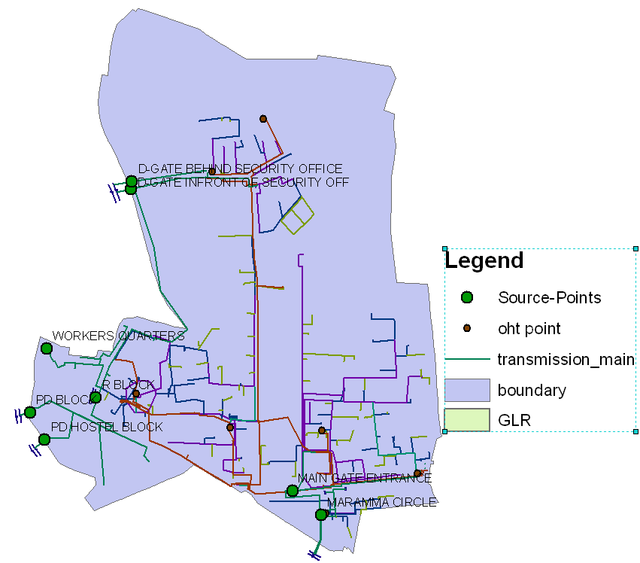pipe network.

Figure 1: BWSSB Inlet points and campus boundary

**Table 1:**BWSSB Inlet connection details

|  |  |  |
| --- | --- | --- |
| **Sl. No** | **Inlet connection Diameter (mm)** | **Remarks** |
| 1 | 300 | Dedicated pumping main, Near main gate of the Campus on the road to Mekhri Circle |
| 2 | 200 | From BWSSB feeder main, on Mathikere Main road |
| 3 | 150 x 2 Nos | From BWSSB feeder main, Near D gate on the road to Mathikere. |
| 4 | 100 | From BWSSB feeder main, Near Maramma circle on NH7 |
| 5 | 50 | From BWSSB feeder main on 8th Main road near Yeshwantpur |
| 6 | 20 x 2 Nos | From BWSSB feeder main on 8th Main road near Yeshwantpur |

**Table 2:** Details of the Over Head Tanks (OHTs)

|  |  |  |  |  |  |  |  |  |  |
| --- | --- | --- | --- | --- | --- | --- | --- | --- | --- |
| **OHT** | **Location/identifying landmark** | **Capacity (Cu.m)** | **No of staging** | **Inlet Dia (mm)** | **Inlet Pipe Material** | **Outlet dia (mm)** | **Outlet Pipe** | **Structure** | **Type** |
| **Material** | **condition** |
| OHT1 | NSSC OHT | 10 | 4 | 100 | CI | 75 | GI | GOOD | Circular |
| OHT2 | TPS OHT | 200 | 4 | 300 | CI | 150 | CI | GOOD | Square |
| OHT3 | Opposite to Kabini Canteen | 10 | 3 | 150 | CI | 300 | CI | GOOD | Triangular |
| OHT4 | A Type quarters | 38 | 4 | 100 | CI | 150 | CI | GOOD | Circular |
| OHT5 | C Mess OHT | 470 | 3 | 150 | CI | 100 | CI | GOOD | Taper Circular |
| OHT6 | Chemical Store | 112 | 3 | 200 | CI | 150 | CI | GOOD | Taper Circular |
| OHT7 | E type quarters | 10 | 7 | 100 | CI | 75 | CI | GOOD | Square |
| Total (Cu.m) | | 850 |  |  |  |  |  |  |  |

The pipe material consists of both GI and CI of about 50% each. There are 12 GLRs and 8 OHTs and their total capacity is about 5200 Cum and 900 Cum respectively. The water stored in GLRs is pumped to the Over Head Tanks (OHT’s) and supplied to the distribution mains. Individual Departments, hostels and housing blocks have small sumps with pumping facility to the roof tanks above their respective buildings.

91 sumps are identified and total capacity of all the sumps is assessed to be about 3023 Cu.m. The capacity of the sumps ranges from 3 Cu.m to 210 Cu.m. Water from the sumps is fed into the roof tanks of individual departments. These tanks are either of reinforced concrete or of PVC. The capacity of the roof tanks varies from 3 Cu.m to 100 Cu.m at different locations. There are 7 number of pumping stations. The capacity of pumps varies from 5 HP to 20HP.

**Table 3:** Details of the Ground Level Reservoirs (GLRs)

| **GLR** | **Location** | **Capacity (Cum)** | **Shape** | **Length/Dia (m)** | **Width (m)** | **Depth (m)** | **Dia**  **(m)** | **Inlet Pipe (mm)** | **Outlet Pipe (mm)** |
| --- | --- | --- | --- | --- | --- | --- | --- | --- | --- |
| GLR-1 | Maramma | 227 | Rectangular | 8.7 | 5.3 | 5.2 | - | 100 | 75 |
| GLR-2 | TPS | 2333 | Rectangular | 27 | 27 | 3.5 | - | 300 | 150 |
| GLR-3 | 375 | Circular | - | - | 3.5 | 12 | 300 | 150 |
| GLR-4 | 375 | Circular | - | - | 3.5 | 12 | 300 | 150 |
| GLR-5 | Main Pumphouse | 234 | Rectangular | 9 | - | 4.3 | - | 200 | 100 |
| GLR-6 | Aerospace Engineering | 444 | Rectangular | 20 | 6 | 4 | - | 200 | 200 |
| GLR-7 | New E Type quarter | 100 | Rectangular | 8 | 5.6 | 2.7 | - | 100 | 100 |
| GLR-8 | Near C Mess | 100 | Circular | - | - | 3.5 | 6 | 200 | 75 |
| GLR-9 | Near B-Type quarters | 200 | Circular | - | - | 10 | 5 | 150 | 75 |
| GLR-10 | Near D-Type quarters | 15 | Circular | - | - | 1.5 | 4 | 150 | 75 |
| GLR-11 | Near D-Type quarters | 15 | Circular | - | - | 1.5 | 4 | 150 | 75 |
| GLR-12 | Near R-Block | 450 | Circular | - | - | 4 | 12 | 150 | 75 |
| Total (Cum) | | 4868 |  |  |  |  |  |  |  |

The distribution network in the campus is a tree type development. Though there are interconnections between the supply mains to various reservoirs, the system does not have a loop connection. The reason for this probably is twofold: (i) that the campus has roughly a rectangular shape and (ii) the period of development of the campus stretches over 100 years. The supply to the distribution network is from OHT or by direct pumping. Bulk Mechanical water meters are installed at all the inlet locations, read once in every month and bills are issued by BWSSB. As the campus consists of both domestic and non-domestic consumption some of the connections are on domestic tariffs while most of the other connections are on non-domestic tariffs.

**Table 4:**Transmission lines

|  |  |  |
| --- | --- | --- |
| **Pipe Dia (mm)** | **Lengths (m)** | **Material** |
| 300 | 1173 | Cast Iron |
| 200 | 10 | Cast Iron |
| 150 | 847 | Cast Iron & MS |
| 100 | 1123 | Cast Iron |
| 75,50,25,20 | 2152 | Galvanized Iron |
| **Total** | **5305** |  |

From the previous literature it is found that the percapita consumption in the Residential Quarters is 130 lpcd, in the Hostels/Mess it is 330 lpcd and Departments and Laboratory it is 272 lpcd. The figure for the hostels is high compared to the norms suggested by CPHEEO. It was found that there is a physical loss of 24.76 percent of water in the campus. This is mainly due to the over flows from OHTs and departmental/residential roof tanks. The physical loss observed appears to be high and this can be minimized by providing level indicators and level controlled stop/start arrangement for pumps to GLRs and OHTs.

The campus has wide tree-lined roads connecting the departments, hostels, housing colony and other facilities. Many departments, bungalows and guest houses have good garden/lawn around the buildings. Total road length inside the campus is 23Km.

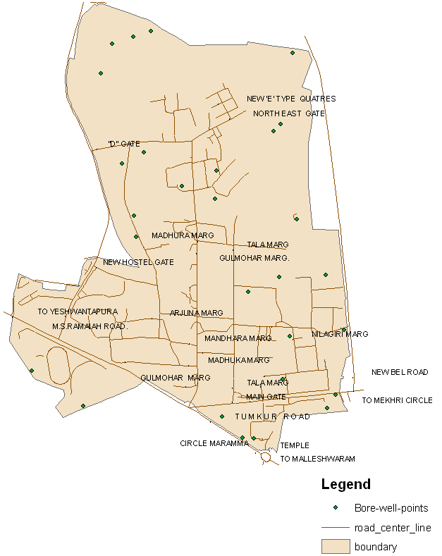

Figure 2: Bore well points and campus boundary

**Ground Water:**

The bore well water supply is mainly used for gardening and for specific non potable uses in some departments. IISc has about 55bore wells (Figure 2) and on an average the water extracted from groundwater is about 0.3 MLD which is about 10% of the piped water supply. The sewage is collected from different locations through an underground sewer network which finally discharges to the BWSSB sewers. The sewers are generally 150 -200 mm diameters with a few short lengths of 300 mm diameter for trunk sewers. In some locations 100mm and 75 mm diameter sewers are also laid. The material of the pipe for smaller diameters is Stone Ware Glazed pipes (SWG) and these are used from 100 mm to 250mm pipes also. RCC pipes of 250-300 mm are also used for sewage disposal.. Around 570 Manholes are provided at necessary locations and total length of sewers is about 13100 meters.

Institute has recently constructed a waste water treatment plant of about 0.5 MLD capacity and the waste water is treated by using submerged membrane technology. This water is supplied to various departments / different locations on the campus for non potable uses through a ring main of diameter 160mm. The pipe material chosen is HDPE of grade PE-100 and PN-10 as there is no heavy traffic. One more recycling plant of capacity 0.5MLD is under construction and should be in operation soon. The treated water from this plant will be injected into the same recycled water distribution line. The recycled water system is shown in Figure 3.

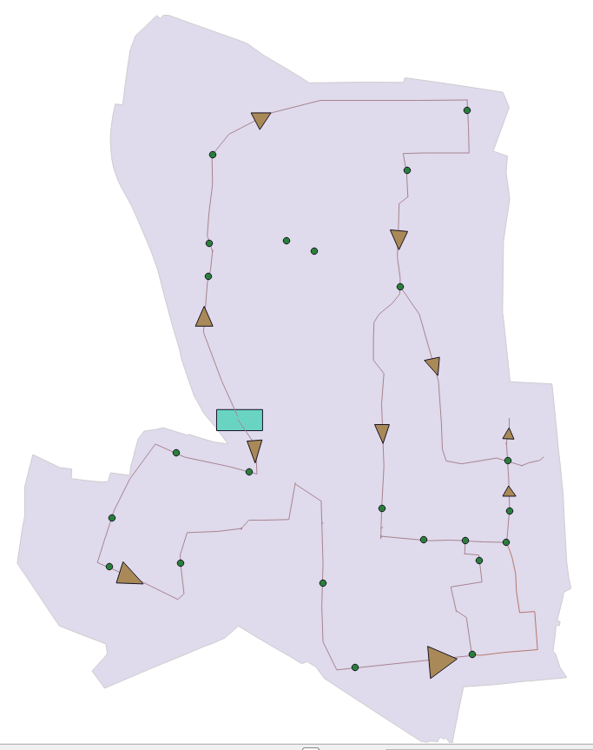

STP

New STP

Figure 3: IISc Recycled water network (0.5MLD) indicating sewerage treatment plant and new

sewerage treatment plant

**Rain Water Harvesting:**

Karnataka State Council for Science and Technology (KSCST) has actively involved in constructing and developing rainwater harvesting structures on the campus. Few of the gardens in the campus are also maintained by using harvested rainwater.

## Table 5: Details of existing Distribution Network

|  |  |  |
| --- | --- | --- |
| **Pipe Dia (mm)** | **Lengths (m)** | **Material** |
| 200 | 714 | Cast Iron |
| 150 | 1768 | Cast Iron & MS |
| 100 | 6656 | Cast Iron |
| 75 | 2720 | Galvanized Iron |
| 50 | 4965 | Galvanized Iron |
| 25 | 3223 | Galvanized Iron |
| 20 | 120 | Galvanized Iron |
| **Total (m)** | **20166** |  |



Figure4: IISc Water Supply Distribution Network.

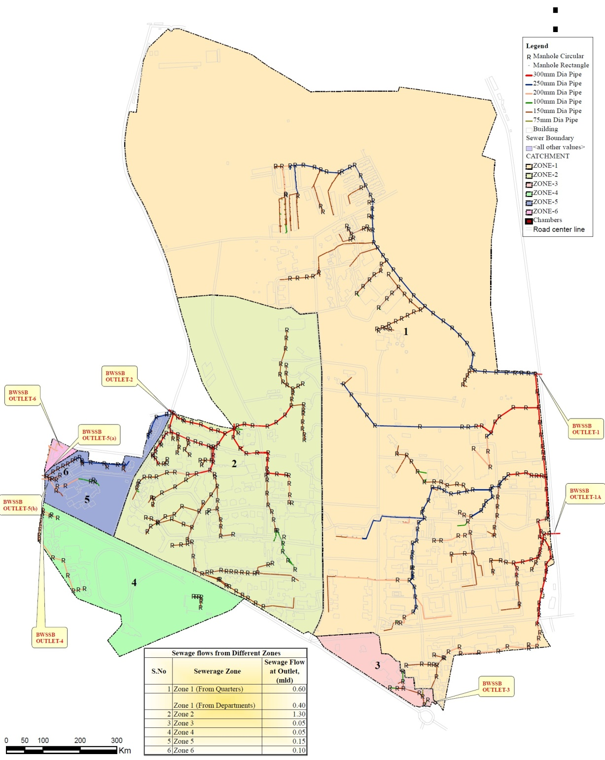

Figure 5:IISc sewer network with manhole positions.

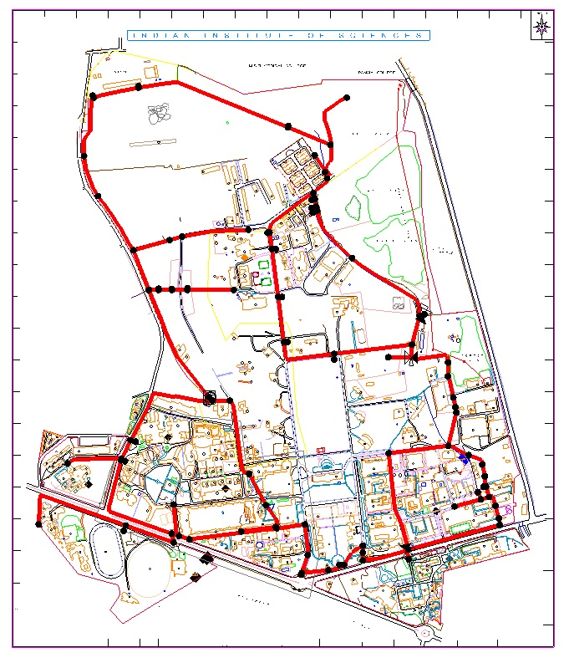

Figure 6: IISc Recycled water distribution network